**Swahili Learning App - Report**

**Project Title:**

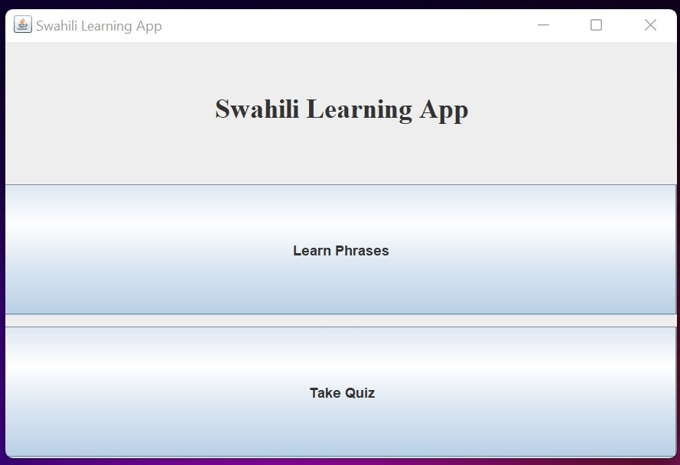Swahili Learning App

**Objective:**

The objective of this project is to develop a simple and interactive GUI-based application to help users learn Swahili, a widely spoken language in East Africa. The app provides a learning section with common phrases, a quiz for reinforcing learning, and feedback on performance.

**Key Features:**

**Learning Mode:**

Displays a list of common Swahili phrases with their English translations.

Users can read and learn essential phrases, which could be useful for beginners.

**Quiz Mode:**

Allows users to test their knowledge of Swahili phrases by translating English phrases to Swahili. Tracks correct answers and presents the score at the end of the quiz.

The quiz shows each English phrase, and users can input their translation in a text field.

**Result Section:**

After the quiz, the user receives feedback on their performance, showing how many answers were correct out of the total. Encourages self-assessment and allows users to retry learning or take the quiz again.

**Navigation:**

Users can easily navigate between the different sections of the app: Main Menu, Learn Swahili, and Quiz.

Simple and intuitive design ensures accessibility.

**Technical Aspects:**

Language & Framework: The program is implemented using Java with Swing for GUI design. Java's JFrame, JLabel, JButton, JTextField, JPanel, CardLayout, and other Swing components are utilized for layout and interactivity.

**Quiz Logic:** The quiz uses a basic LinkedHashMap to store Swahili phrases as key-value pairs (English as the key and Swahili as the value), and sequentially asks the user to translate them.

**Event Handling:** Event listeners are used to handle user inputs, such as button clicks for navigation and answer submission.

**UI Design:**

Simple & User-Friendly:

The application uses a clean, easy-to-understand interface, allowing the user to access features without any prior training.

**Conclusion:**

The Swahili Learning App provides a great start for beginners learning Swahili by offering a structured approach to familiarize users with common phrases and test their knowledge. It helps users learn at their own pace, with the option to practice, self-test, and evaluate progress.